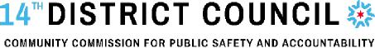
2026 MEETING CALENDAR
Share your ideas and experiences to help shape policies that improve police accountability, restorative justice, and evidence-based approaches to community safety at our meetings!

DATE / TIME | MEETING LOCATION  (Meeting dates & locations may change, please check for updated notices as meeting dates get closer)
Saturday, January 3rd, 1:00 PM | Humboldt Park Library - 1605 N Troy
Saturday, February 7th, 1:00 PM | Logan Square Library – 3030 W Fullerton
Saturday, March 7th, 1:00 PM | Wicker Park-Bucktown Library – 1701 N Milwaukee
Saturday, April 4th, 1:00 PM | Humboldt Park Library – 1605 N Troy
Saturday, May 2nd, 6:00 PM | Logan Square Library – 3030 W Fullerton
Thursday, June 4th, 6:00 PM | TBD
Thursday, July 9th, 6:00 PM | TBD
Thursday, August 6th, 1:00 PM | TBD
Saturday, September 5th, 1:00 PM | Wicker Park-Bucktown Library – 1701 N Milwaukee
Saturday, October 3rd, 1:00PM | Humboldt Park Library – 1605 N Troy
Saturday, November 7th, 1:00 PM | Logan Square Library – 3030 W Fullerton
Saturday, December 5th, 1:00 PM | Wicker Park-Bucktown Library – 1701 N Milwaukee

Reach your elected District Councilors at DC014PublicComment@gmail.com and DC14@CityofChicago.org

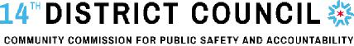
District Boundaries
North to Belmont and south to Division
West to Central Park and east to the Chicago River
